**HTML exercise 1**

**The first task is to practice the main HTML tags.**

Example of first task is here

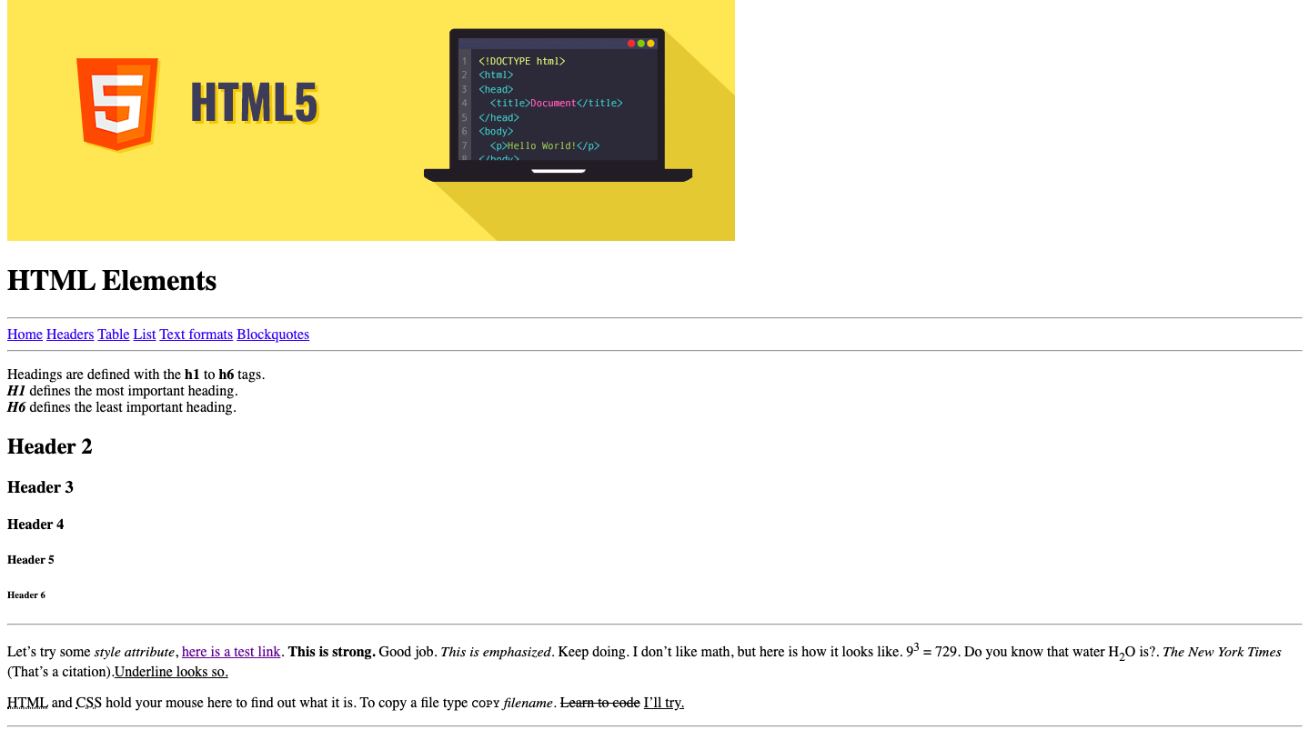

# HTML exercise 2

**First experience of creating a site on HTML.**

Example of second task is here

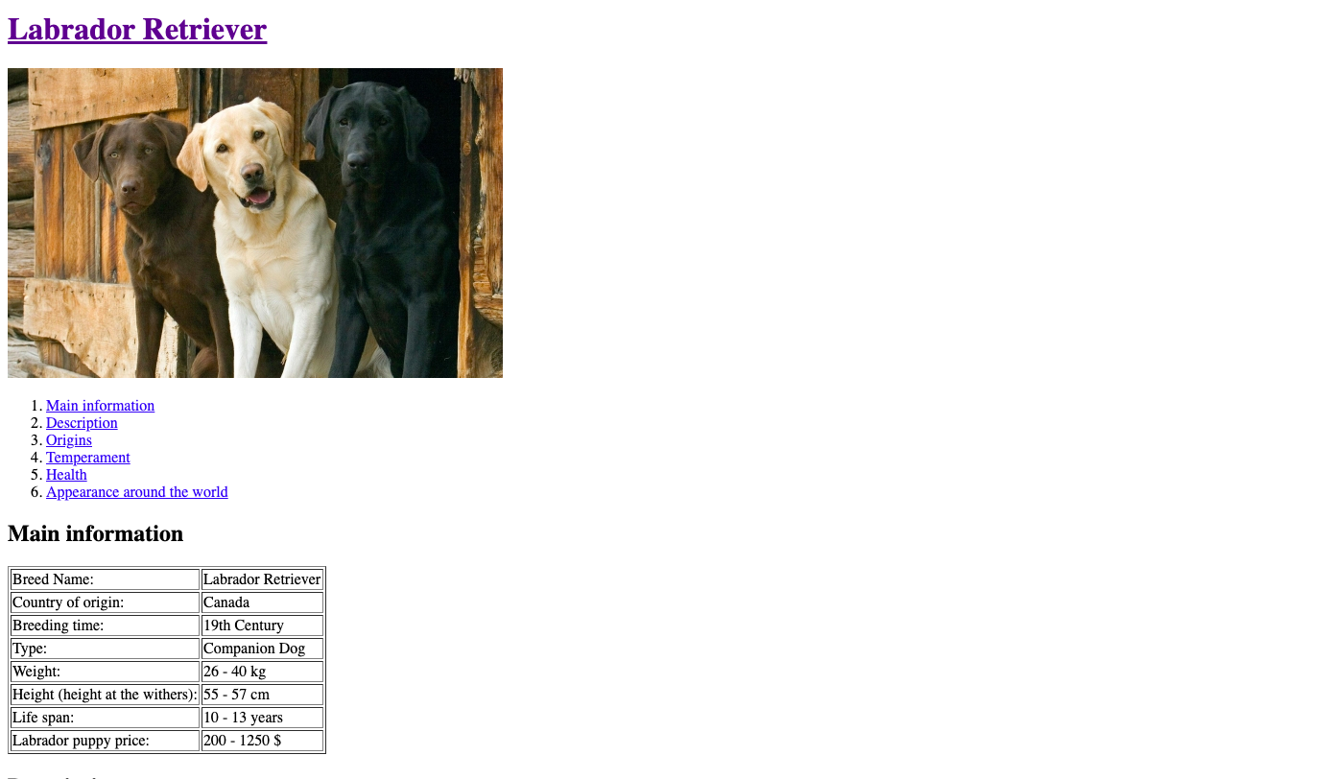

# CSS exercise 1

**The fifth task is for practicing grid model in css.**

Example of the second task is here

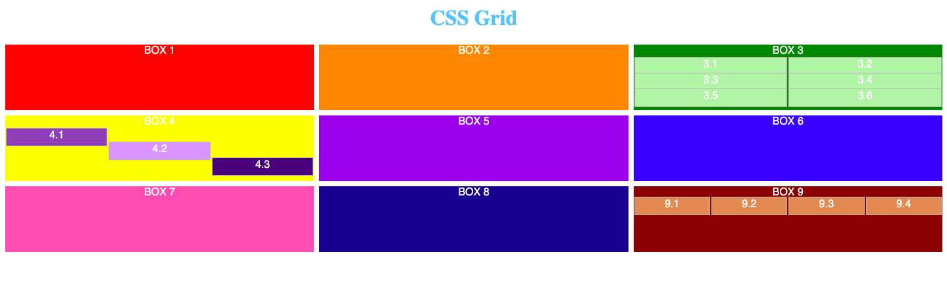

# CSS exercise 2

**The third task is for practicing selectors in css.**

